1. **So far we did**:
   1. We exposed RESTful End-Point.
   2. Added just spring security starter dependency. So default security configuration from Spring Security was applied.
2. **Agenda**:
   1. We will explore one more feature of Spring security to make our life easy with the help of tokens and cookies that it is going to use internally.
3. See, we entered the credentials only once. Now no matter how many times we refresh the browser, the app doesn’t ask for credentials.
   1. It is because spring security generates a token (in this case JSESSIONID) and shares with the client (such as browser) who makes the request.
   2. And browser is smart enough to send that token with each subsequent request.
   3. This is because of the power of token ID that is used by Spring Security in the back-end.
4. Let’s see how it works. Let’s go to the POSTMAN App.
5. 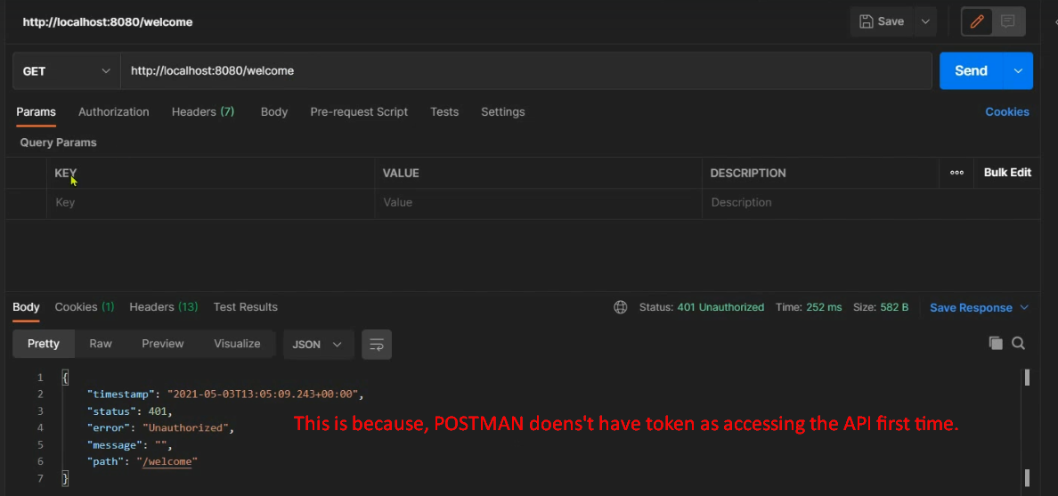
6. 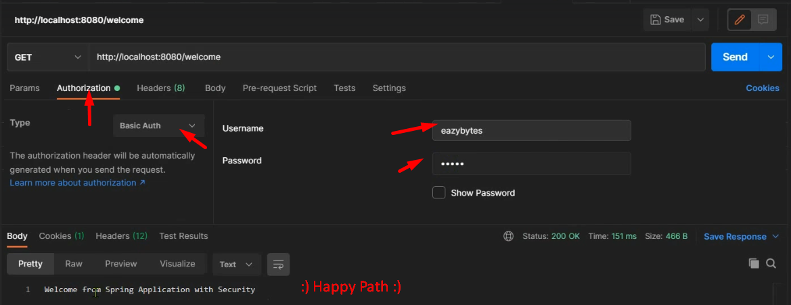
7. 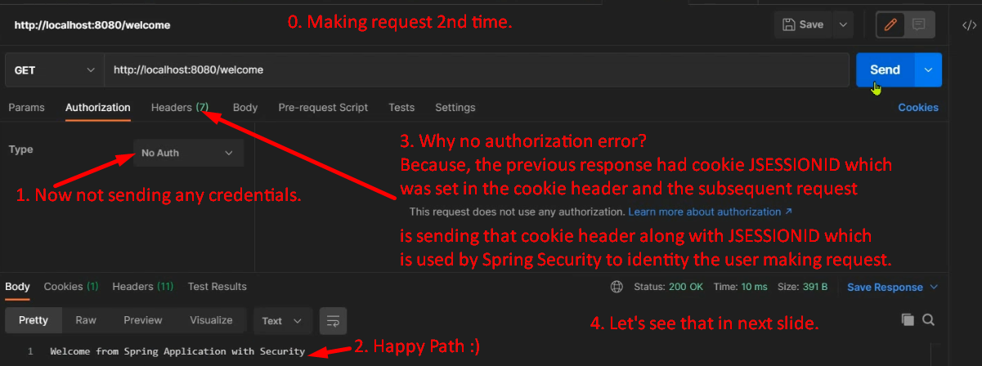
8. 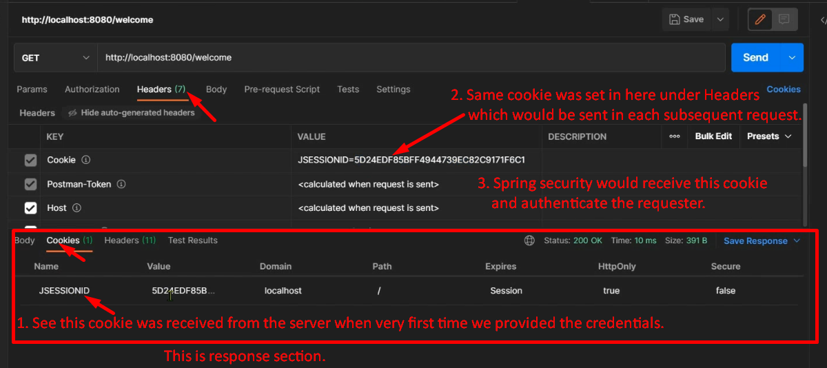
9. 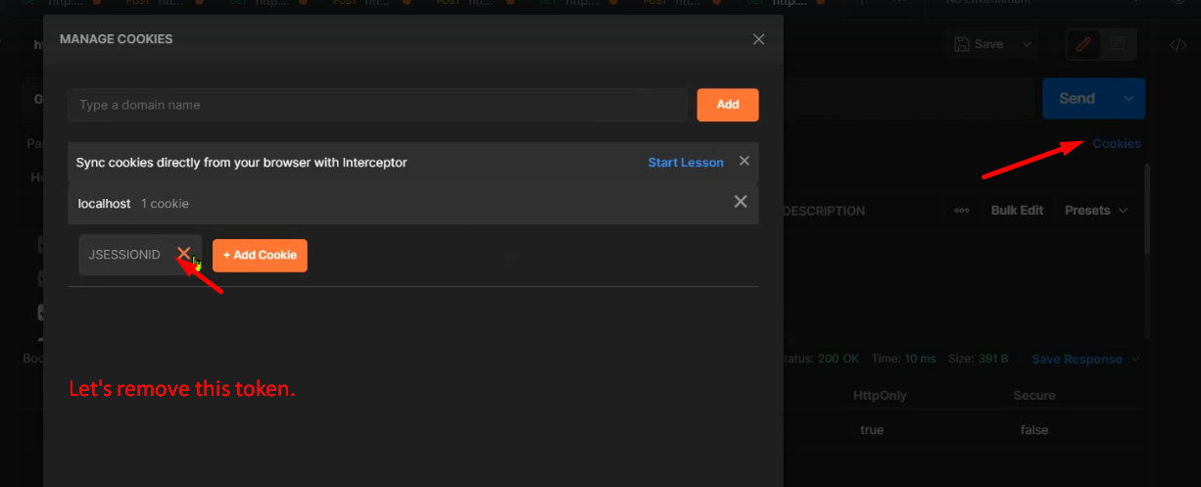
10. 